**LOCKING/ UNLOCKING OF DOOR USING ARDUINO**

**Introduction**

The modern design of smart homes has focussed on smart controls and to convert conventional switches to centralized control system. The smart home technologies have focused on networking, controlling and smart devices (green, energy consumption, security, environment, and entertainment). The remote controllers have been used in various services such as home appliances, to reduce power consumption, communication and security. Smart door lock is considered as a smart access control based on authentication of person to lock/unlock the door in smart home. One of the biggest advantages of design smart door lock is to control the opening and closing of door by an authenticated person. The connection between smart phone and door controller is based on Bluetooth technology. In this project we are providing enough security to satisfy the user’s needs. The user will be prompted to enter a password to unlock the door. On successful password entry, the door unlocks for a specified amount of time enabling him/her to store or restore his/her valuables. On the other hand, if the user enters an invalid password then corresponding equivalent message will be displayed.

**Why did we decide to make this project**

The project was to make it easy to open and close a door with the help of mobile phone or Bluetooth module which otherwise is a very boring task to do again and again.

We have done this by creating a compact and cheap device that can open or lock door accordingly. We can control the door lock by any mobile phone or Bluetooth module. Arduino board is connected to a 9V battery which will power the Arduino. The Arduino Board is programmed using C language in Arduino IDE software.

**Materials and methods**

Components Used:

* Hardware:

1.Arduino UNO Board :

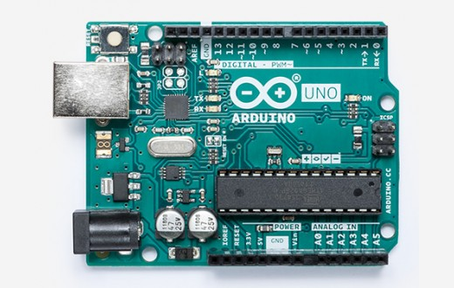

The Arduino UNO Board is a widely used open source microcontroller board based on the Atmega328P microcontroller and developed by Arduino.cc. The board is equipped with sets of digital and analog equipments. The board features 14 digital pins and 6 Analog pins. It is programmable with the Arduino IDE (Integrated Development Environment) via a type B USB cable. It can be powered by USB cable or by external 9volt battery.

2.Bluetooth module

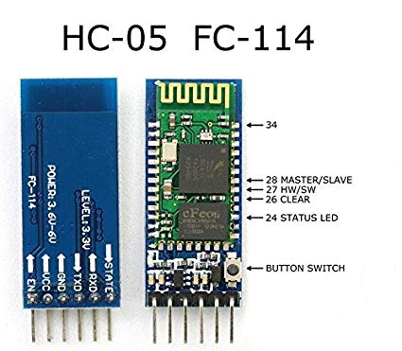

HC-05 module is an easy to use Bluetooth SPP (serial port Protocol) module. It is designed for transparent wireless and serial connection setup. The serial port Bluetooth module is fully qualified Bluetooth V2.0 + EDR (enhanced data rate) 3Mbps Modulation with complete 2.4GHz radio transceiver and baseband.

3.Resistors

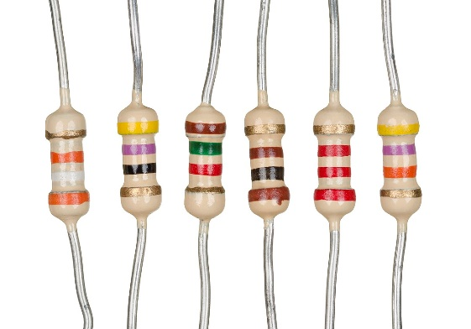

4.Breadboard:

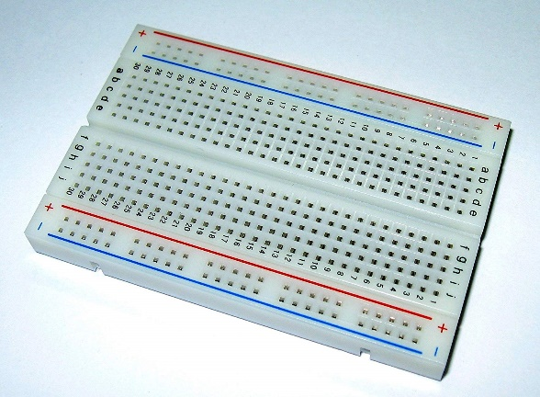

A breadboard is a solderless device for temporary prototype with electronics and test circuit designs. Most electronic components in electronic circuits can be interconnected by inserting their leads or terminals into the holes and then making connections through wires where appropriate.

5. Jumper Wires

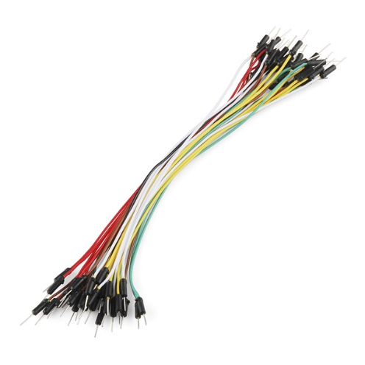

6.Hinges and Door Lock

7.12 volt battery for powering the Arduino

8.Motor control lock

9.A wooden setup of door

10.Transistors

11.IC :

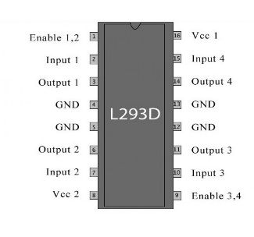

**Mechanical materials:**

1.Wood

2.L-bends

3.Screws

4.Acrylic sheet

5.Nuts

6.2 doors

7.Hinges

8.Fevicol

* Software

1.Arduino IDE

2.Fritzing : Fritzing is an open source hardware initiative that makes electronics accessible as a creative material for anyone. It is a software tool and a community website for processing and Arduino ,fostering a creative ecosystem that allows users to document their prototypes, share them with others ,teach electronics in classroom, and layout and manufacture professional pcbs.

Methods:

Circuit Designing:

Step 1:

A Bluetooth module HC – 05 , IC -L239D ,DC motor, battery ,power supply , Arduino are used.

Step 2:

1.In IC L239D – pin 9 and 16,Bluetooth module HC-05 VCC are connected to Arduino 5V .

2.IC 10th and 15th input pins are connected to 8th and 9th pin of Arduino.

3. 11th and 14th output pins of IC are connected to motor.

4.Vin is connected to 8th pin and a power supply of 12V.

5.12th and 13th pin of IC and HC-05 ground are connected to Arduino ground pin.

Step 3:

RX terminal of Bluetooth module is connected to TX terminal of Arduino. TX terminal of Bluetooth module is connected to RX terminal of Arduino.

Step 4:

They are modelled on breadboard and then on PCB.

Software:

Step 1:

Arduino IDE is used

Step 2:

Open Arduino IDE . Verify it the code first, if there is error then recheck it ,if error is not there then upload it.

Step 3:

Clicking on 1 will lock the door and clicking on 0 will unlock it.

**Schematics**

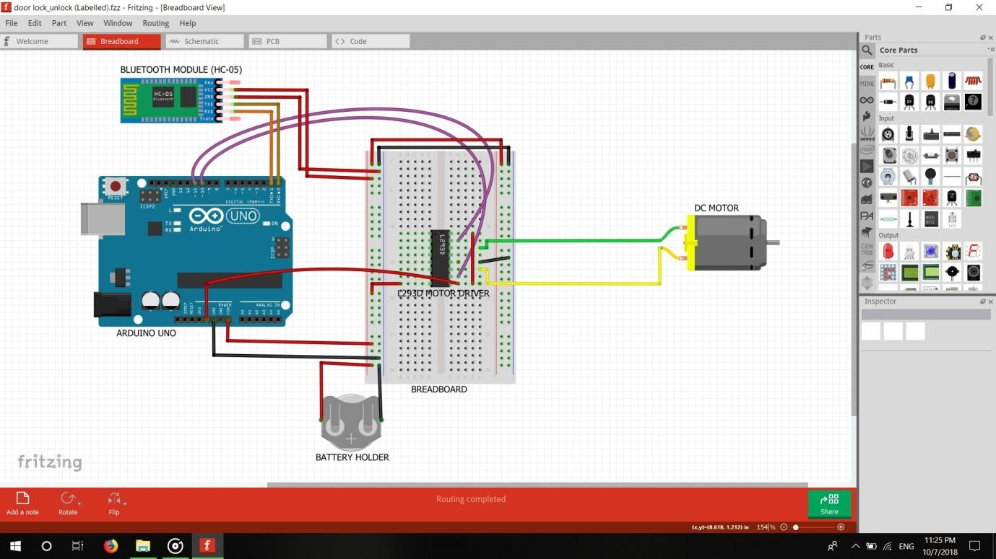

**Cad Model**

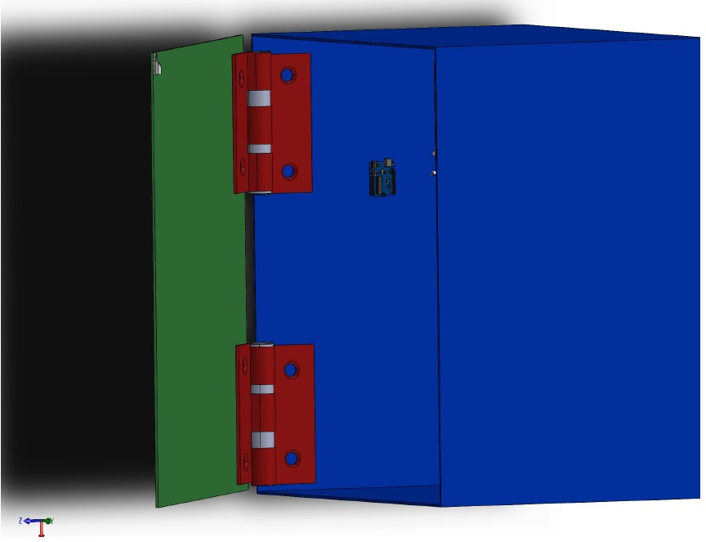

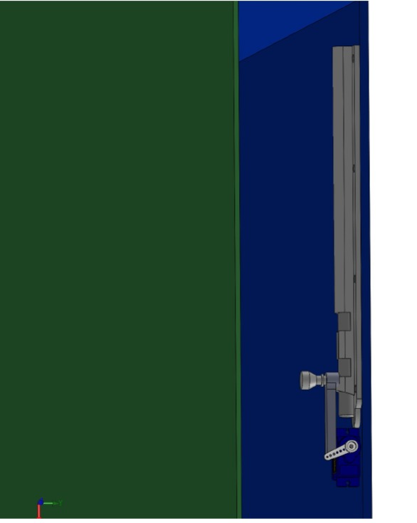

**Steps:**

1.Taking first base of house of dimensions are 31cm*23cm.

2.Taking one side wall 25cm*23cm.

3.Take another side wall 29cm*23cm.

4.Then on base fix the two side walls.

5.Then make a hinge dimension.

6.Assemble the one side wall and door.

7.Then make the door of dimensions

8.Assemble the door with house.

9.Fixing of electronic components.

10.Then cover the back wall with acrylic sheet.

**Future scopes**

1. It can be used in every household or in office to minimize the human efforts and can save a lot of time.
2. It nullifies the risk of keys getting lost or stolen.
3. As the system is online, a person can lock/unlock doors from anywhere around the world at his own convenience.
4. It can also be used by physically disabled people.
5. A rechargeable battery can be provided which can give power backup of 3-4hrs in case of power failure.
6. GSM and GPS system can be used in case someone tries to hack the lock password/ cause any physical damage.
7. The GPS and GSM system would track the thief's location & also our location, thus sending us an alert message regarding the attack on our smart-lock.
8. It can also be implemented using cloud computing where user can control the lock irrespective of his location.
9. Use of camera can also be done for surveillance. For further security, finger scanner, face recogniser etc can be used.